ECE 2049 – Laboratory Report
Embedded Computing in Engineering Design
Worcester Polytechnic Institute
C-Term 2021
Section: C03
Laboratory 4
SPI Communication
Submitted by:
__________________________
Jonathan R. Lopez

ECE Mailbox #178
______________
3/10/2021

Professor: Yarkin Doroz

Co-Instructor: Fatemeh (Saba) Ganji
Introduction:

The purpose of lab 4 is to make two SPI modules (one Master and one Slave) using our MSP430F5529, our keypad, our buzzer, potentiometer and our SHRP128 LCD screen. We will be using the 12-bit ADC converter on the MSP430 to get the voltages from the potentiometer.

Materials:

TI MSP430F5529 Launchpad based lab board.
Jumper wires
Buzzer
Breadboard
Potentiometer
Sharp128 LCD Screen
0-9, * and # Keypad
Micro-USB to USB-A cable
Computer with Code Composer Studio ver. 10.2

Discussion and Results:

Getting started:

Wiring is a little different with this lab. Figures 1 and 2 show the new wiring.

Approach:

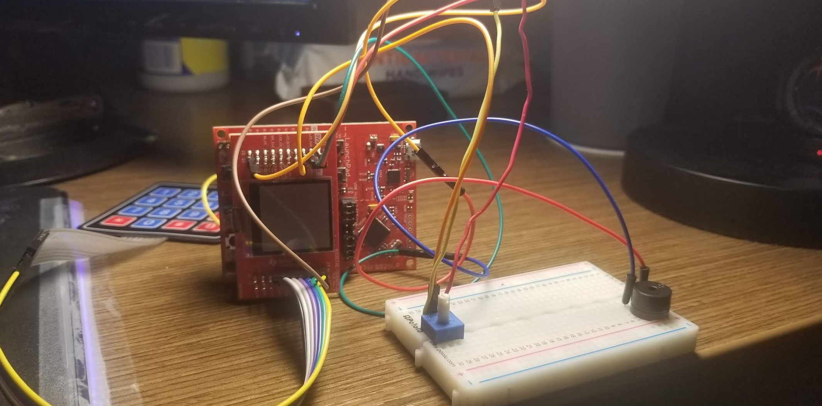

Figure 1: MSP430F5529 wired up and ready for Lab 4

To set up the Slave and master we needed to connect pins on the back of the MSP430 to each other. Figure 3: shows the pins for the Master/slave communication and Figure 2 shows the MSP430 wired up for SPI communication.

The potentiometer also needed to be wired up. We will use P6.4 which is input channel A4. We will keep a note of this when we set up the ADC for the potentiometer “scroll wheel”.

Figure 1: shows the front of the MSP with the potentiometer wired up. VCC is connected to the 3V3 pin for a source voltage of 3.3V and the wiper or middle pin is connected to P6.4. The VEE is connected to a ground pin the MSP.

The pin setup for the LCD is already configure in the configDisplay (); function

From Lab 3 we will use a timer that counts every second. We will utilize timmerA2 like in the previous 2 labs

Setup for timerA2 can be found in Figure 4 and the #pragma statement can be found in Figure 5.

The whole schematic of this lab can be found in Figure 6.

With the wiring out of the way we can launch CCS and start programming.
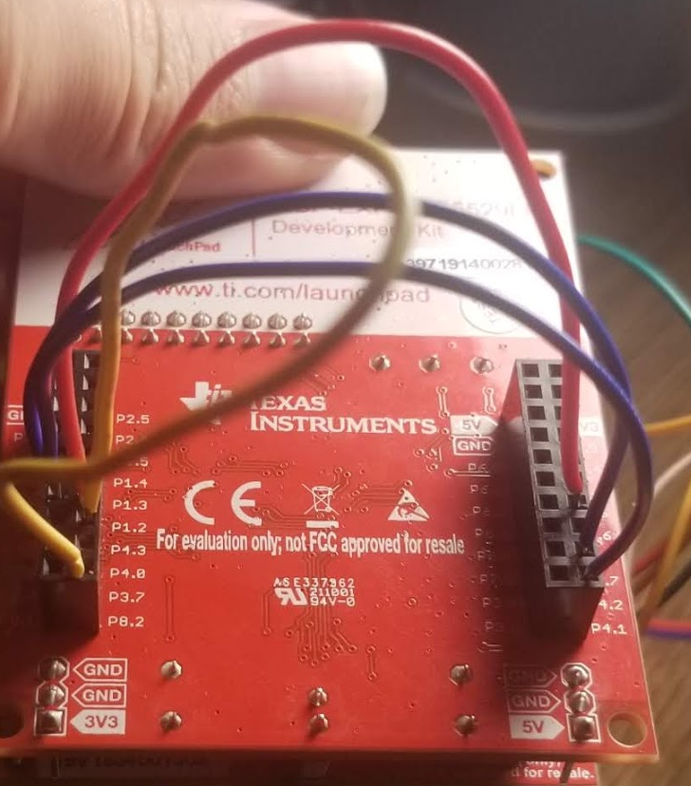

Figure 2: Pin setup for Master/Slave Communication

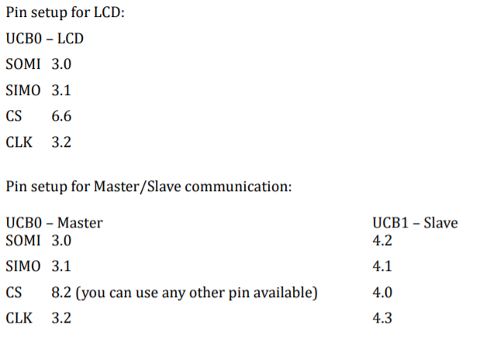
Figure 3: Pin setup for Master/Slave Communication and Pin set up for LCD

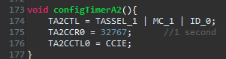

Figure 4: void configTimerA2();

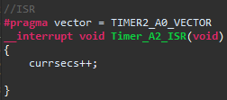

Figure 5: ISR

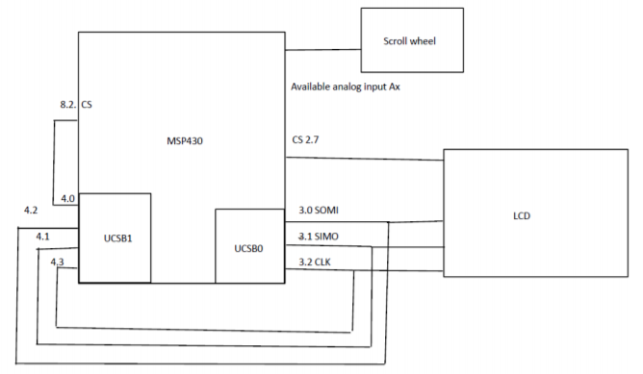

Figure 6: Lab 4 Schematic (Note Ax in this case is A4)

How will you map the output of the scroll wheel to voltage? Explain in your report?

We will map the scroll wheel to a voltage by taking the code and converting it to a voltage using the source voltage and the 12-bit ADC that’s on board the MSP430. The configuration for the ADC can be found in Figure 7: and the float potVolts(); function can be found in Figure 8: The functions take the code produced by the ADC and turn it into a float value for voltage across the potentiometer. We will then take this information and put it through the master and slave devices. It needs 4 reads and writes to get the information across since it can only take 1 byte at a time. There are 8 bits in a byte. Floats are 32 bits. There’s some converting to get the floats into 4 bytes. Each byte I stored in an unsigned char to be put through the master and slave. This conversion is shown in Figure 13. After shifting the bits and getting them into their own variables, they are written by the master and read by the slave.

void MasterSPIWrite (unsigned int data); will take care of the writing and
unsigned char SlaveSPIRead(); will take care of the reading.

After some debugging, I was able to get the test one working and then the timer and finally the voltage. The test SPI code can be found in Figure 9. The test one was verified using the debugger.

void MasterSPIWrite (unsigned int data); can be found in Figure 10.

unsigned char SlaveSPIRead(); can be found in Figure 11.

void InitSlaveSPI();can be found in Figure 12.
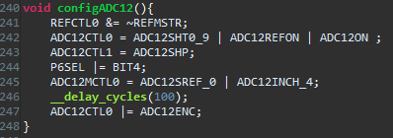

Figure 7: void configADC12();

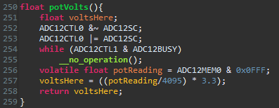

Figure 8: float potVolts();

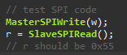

Figure 9: Test SPI Code

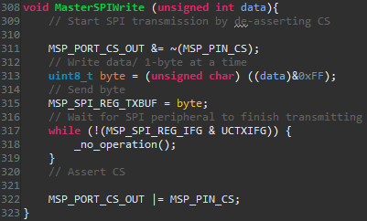

Figure 10: void MasterSPIWrite (unsigned int data);
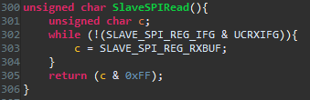

Figure 11: unsigned char SlaveSPIRead();

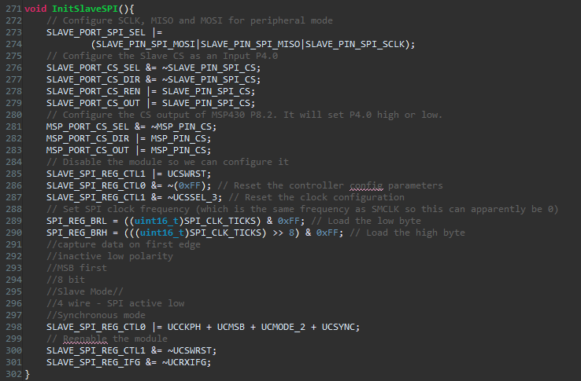

Figure 12: void InitSlaveSPI();

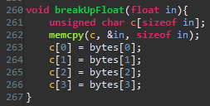

Figure13: Float to 4 bytes.

That unsigned int for the timer will then be put through the same functions as the bytes for Voltage. It will also take 4 reads and writes to get the information across since
unsigned long int are also 32 bits. It takes 1 byte at a time. There are 8 bits in a byte. Each byte will be stored in an unsigned int

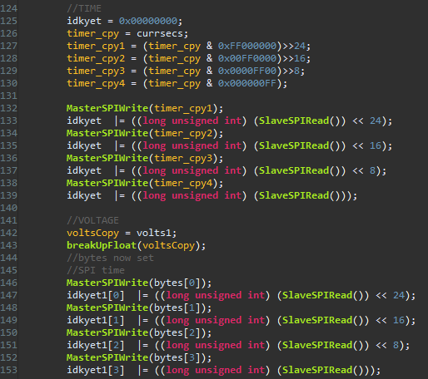

Figure 14: SPI for both the timer and voltage
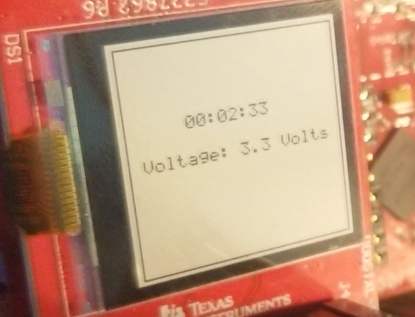

Figure 15: Timer and Voltage displayed on the MSP430

I’ve attached the signoff video on canvas along with this report and code in a zip file.

Summary and Conclusion:

In conclusion, this lab had the purpose of getting students more familiar with the interrupts, timers, SPI, the C programming language and the environment of Code Composer Studio as well as get the hang of using the builder, debugger and the variable window within Eclipse/CCS. This concludes this laboratory experiment with the SPI Communication lab on the MSP430F5529 using the buzzer, potentiometer, keypad, and Code Composer Studio.

Appendices

ASCII table:

Lab 4 Handout:
https://canvas.wpi.edu/courses/23392/files/3597862?wrap=1

Demo Project:
https://canvas.wpi.edu/courses/23392/files/3416786?wrap=1

CCS download:
https://software-dl.ti.com/ccs/esd/documents/ccs_downloads.html

CCS tutorial:
https://www.youtube.com/watch?v=2W0ZHO0vzJE

MSP430 user guide:
https://canvas.wpi.edu/courses/23392/files/3432903?wrap=1

C Review pdf
https://canvas.wpi.edu/courses/23392/files/3439859?module_item_id=542026

ECE 2049 Lab BOM:
https://canvas.wpi.edu/courses/23392/files/3411701?module_item_id=527923

ECE 2049 Course Information:
https://www.wpi.edu/academics/calendar-courses/course-descriptions/17856/electrical-computer-engineering#ECE-2049

Potentiometer Data Sheet:
https://www.digchip.com/datasheets/parts/datasheet/1064/WIW3362-R-102-pdf.php
